# Instructions

The web development team has requested that you install CentOS Linux on the system you created for them. Please install the system with a graphical user interface. Please ensure the hostname is set to the same name you created for the virtual machine and that the network is turned on during the installation process. Create an account with your username and set the password for this account and the root account to Pa$$w0rd.

Test the system by logging in with your account and running the command "ping 8.8.8.8" when completed. Hit Ctrl-C to stop the ping command from running.

# Screenshots

Paste the required screenshots under each description.

1. Paste a screenshot of the bash prompt showing your username, correct system name, and the ping command running successfully.

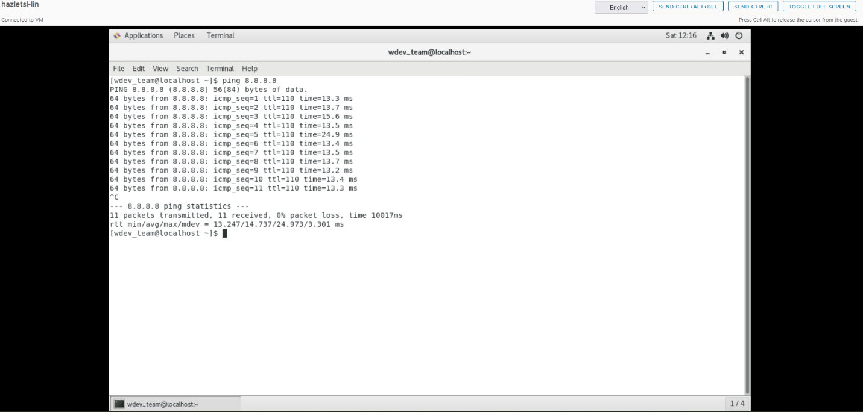

# Documentation

Record and explain all the steps you took to complete the task. Include any commands used, screenshots showing GUI interfaces, or any other information that would help you recreate the task.

**Note: You will be allowed to use this documentation to help you complete future assignments.**

* Set the root password to Pa$$w0rd.
* Created a new user with a username, wdev_team, and set the password to Pa$$w0rd.
* After confirming the settings, I clicked Begin Installation to start the process.
* Once the installation was complete, the system rebooted. I made sure to remove the installation media (ISO file) so the VM would boot from the installed CentOS system.
* The system booted into the graphical interface, and I logged in using the user account I created during installation.
* Pinged 8.8.8.8 I ran the following command to test network connectivity
* Took a screenshot and finished the lab